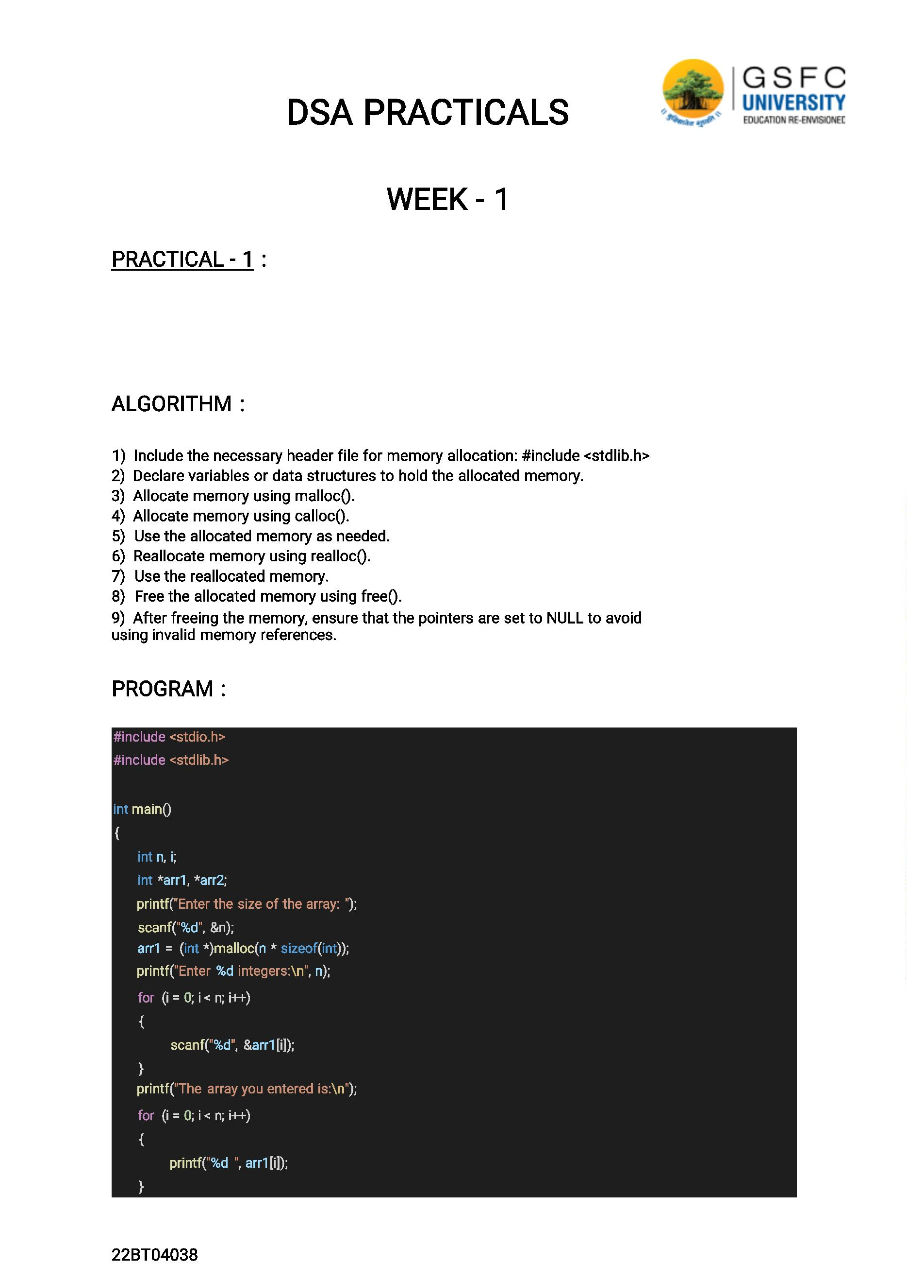

DSA PRACTICALS

WEEK - 1

PRACTICAL - 1 : WAP to demonstrate the use of dynamic

memory allocation. DMA functions malloc(),calloc(), Realloc,

free().

ALGORITHM :

1) Include the necessary header file for memory allocation: #include <stdlib.h>

2) Declare variables or data structures to hold the allocated memory.

3) Allocate memory using malloc().

4) Allocate memory using calloc().

5) Use the allocated memory as needed.

6) Reallocate memory using realloc().

7) Use the reallocated memory.

8) Free the allocated memory using free().

9) After freeing the memory, ensure that the pointers are set to NULL to avoid

using invalid memory references.

PROGRAM :

#include <stdio.h>

#include <stdlib.h>

int main()

{

int n, i;

int *arr1, *arr2;

printf("Enter the size of the array: ");

scanf("%d", &n);

arr1 = (int *)malloc(n * sizeof(int));

printf("Enter %d integers:\n", n);

for (i = 0; i < n; i++)

{

scanf("%d", &arr1[i]);

}

printf("The array you entered is:\n");

for (i = 0; i < n; i++)

{

printf("%d ", arr1[i]);

}

1

printf("\n");

free(arr1);

printf("\nEnter the size of the array: ");

scanf("%d", &n);

arr2 = (int *)calloc(n, sizeof(int));

printf("Enter %d integers:\n", n);

for (i = 0; i < n; i++)

{

scanf("%d", &arr2[i]);

}

printf("The array you entered is:\n");

for (i = 0; i < n; i++)

{

printf("%d ", arr2[i]);

}

printf("\n");

free(arr2);

int *arr3 = (int *)malloc(5 * sizeof(int));

printf("\nInitial array of size 5:\n");

for (i = 0; i < 5; i++)

{

arr3[i] = i + 1;

printf("%d ", arr3[i]);

}

arr3 = (int *)realloc(arr3, 8 * sizeof(int));

printf("\nArray after reallocating to size 8:\n");

for (i = 0; i < 8; i++)

{

printf("%d ", arr3[i]);

}

printf("\n");

free(arr3);

return 0;

}

OUTPUT :

Enter the size of the array: 4

Enter 4 integers:

1 2 3 4

The array you entered is:

1 2 3 4

22BT04038

2

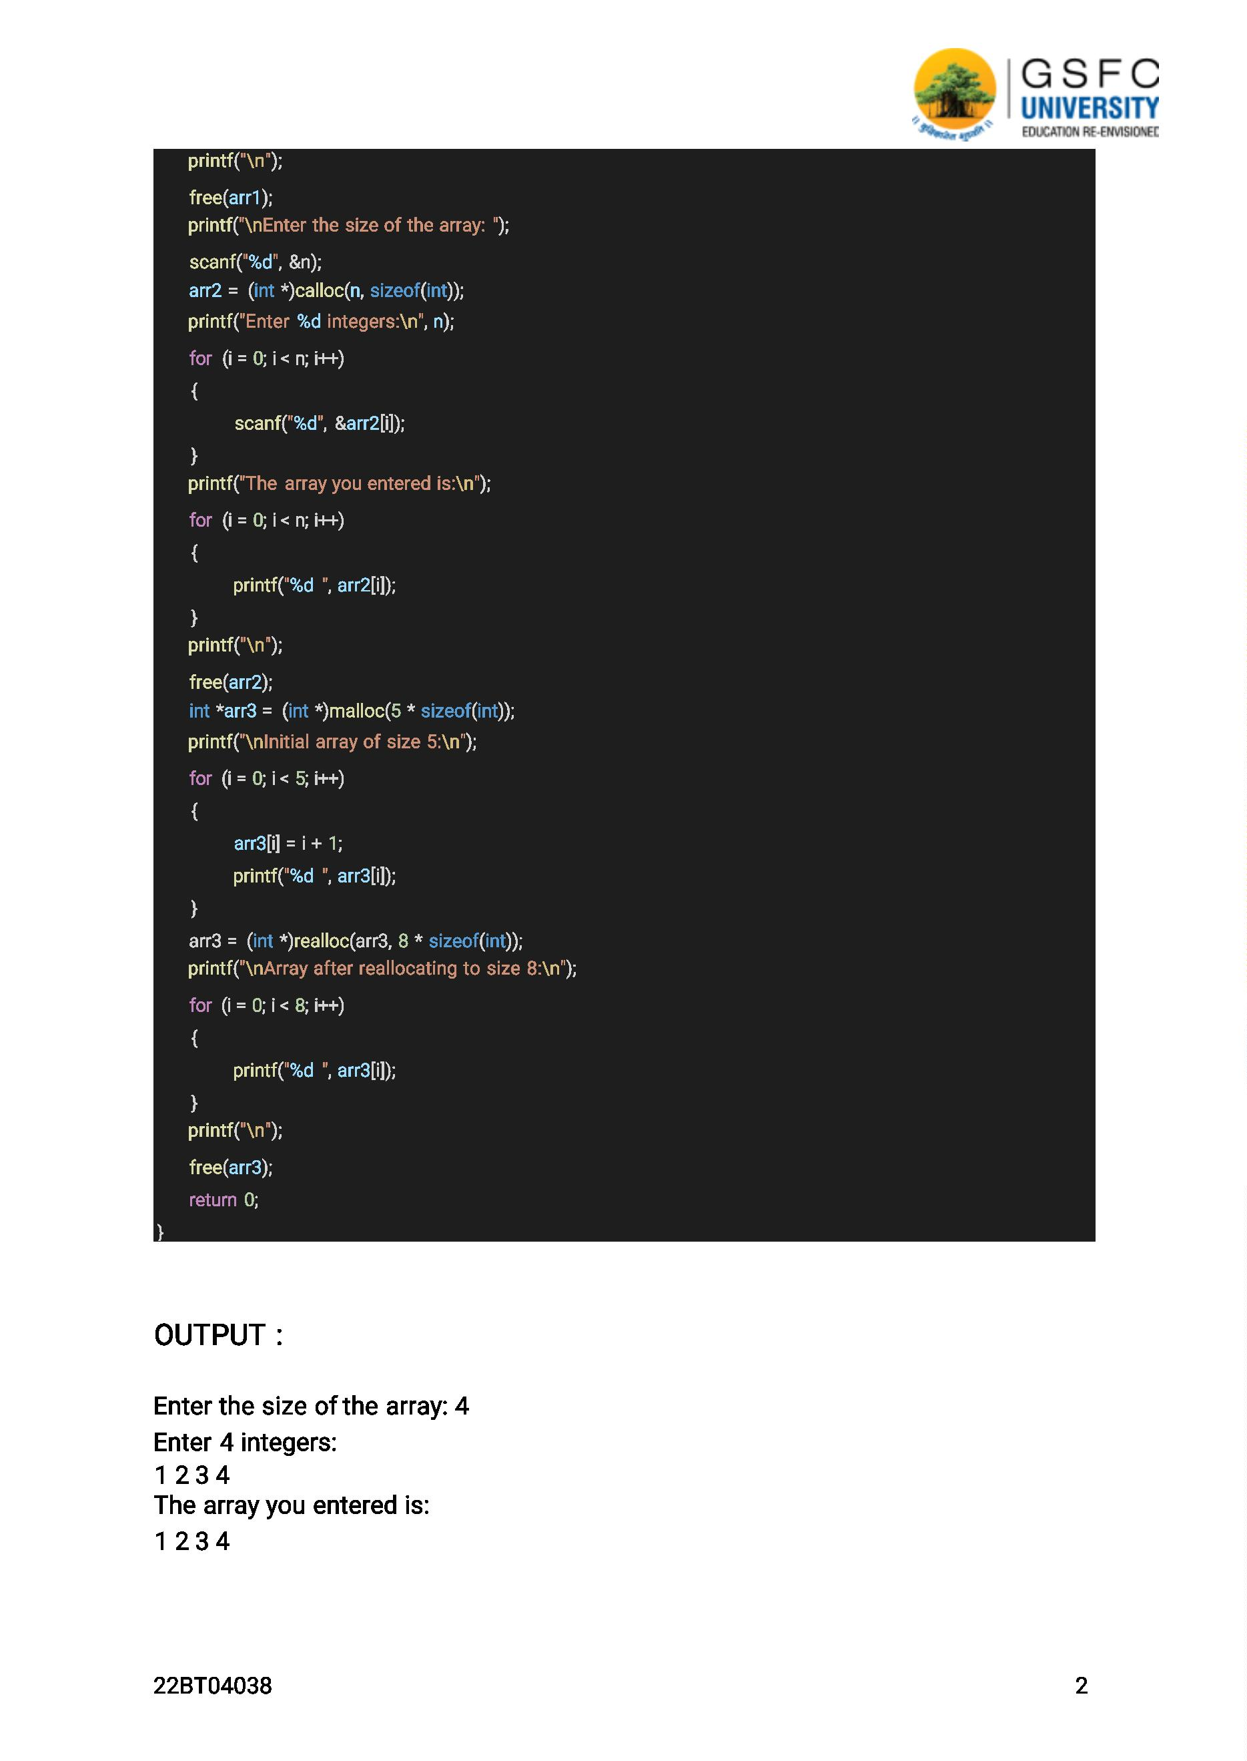

Enter the size of the array: 3

Enter 3 integers:

5 6 7

The array you entered is:

5 6 7

Initial array of size 5:

1 2 3 4 5

Array after reallocating to size 8:

1 2 3 4 5 0 0 0

WEEK - 2

PRACTICAL - 1 : WAP to insert the group of numbers at the given

position in an array.

ALGORITHM :

1) Start

2) Read the size of the array (size)

3) Read the position at which the group should be inserted (pos)

4) Read the size of the group of numbers (groupSize)

5) Create an array of size (size + groupSize) to accommodate the new group of numbers

6) Read the elements of the original array of size (size)

7) Read the elements of the group to be inserted (group)

8) Shift the elements in the original array to the right from position (pos) to

(size - 1) by (groupSize) positions

a. Start from the last element of the original array and move towards the position (pos)

b. Move each element to the right by (groupSize) positions

9) Insert the group of numbers into the original array at position (pos)

●

●

Start from position (pos) and move towards position (pos + groupSize - 1)

Replace each element with the corresponding element from the

group of numbers

10) Print the modified array

11) Stop

PROGRAM :

#include<stdio.h>

int main()

{

int arr[10],i,num,pos;

22BT04038

3

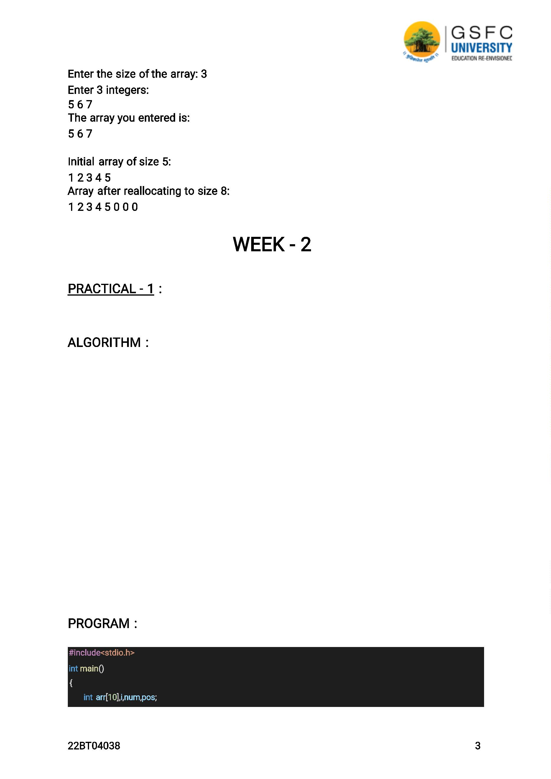

printf("Enter the array elements.");

for(i=0;i<10;i++)

{

scanf("%d",&arr[i]);

}

printf("The array elements are:");

for(i=0;i<10;i++)

{

printf("%d",arr[i]);

printf("\n");

}

printf("Enter the value to insert.");

scanf("%d",&num);

printf("Enter the Position where to insert.");

scanf("%d",&pos);

for(i=10;i>=pos;i--)

{

arr[i]=arr[i-1];

}

arr[i]=num;

printf("The array Elements after inserting.\n");

for(i=0;i<10;i++)

{

printf("%d\n ",arr[i]);

}

}

OUTPUT :

Array before insertion: 1 2 3 4 5

Array after insertion: 1 2 6 7 8 3 4 5

22BT04038

4

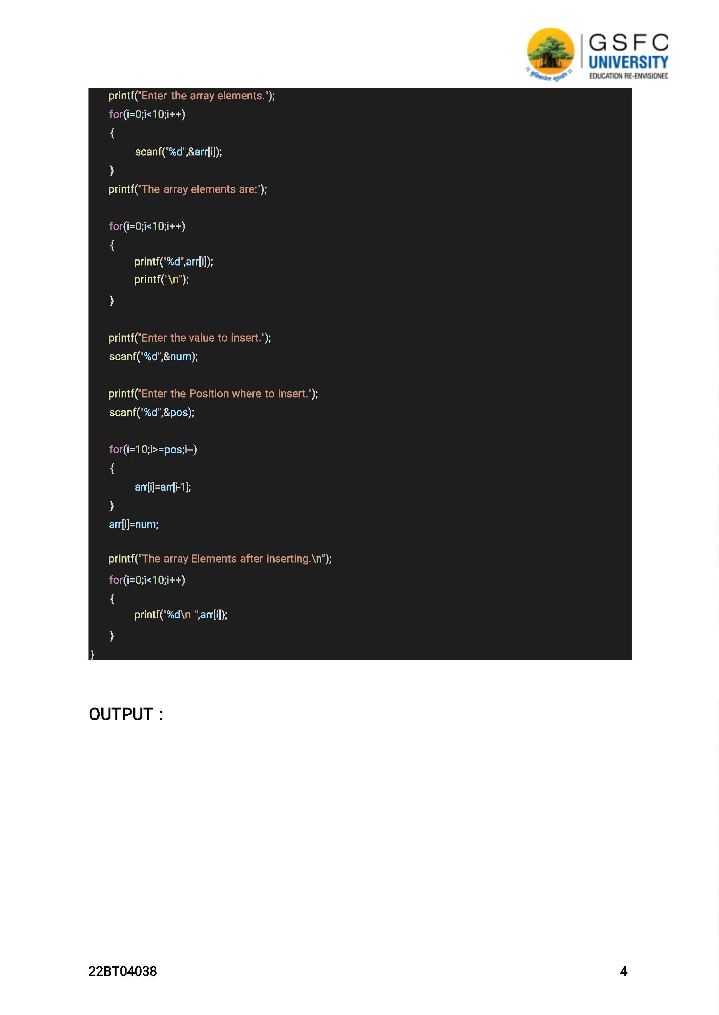

PRACTICAL - 2 : WAP to replace a substring with another substring in

the given string.

ALGORITHM :

1) Start with the input string, the substring to be replaced, and the new substring.

2) Find the position/index of the first occurrence of the substring in the input

string. If the substring is not found, exit or handled accordingly.

3) Create a new string or character array to hold the modified string.

4) Copy the characters from the beginning of the input string up to the position

of the substring into the new string.

5) Append the new substring to the new string.

6) Skip the characters in the input string corresponding to the length of the

substring that needs to be replaced.

7) Copy the remaining characters from the input string after the position

of the substring into the new string.

8) The new string now contains the modified string with the replaced substring.

PROGRAM :

#include <stdio.h>

int main()

{

char str[200], pat[20], new_str[200], rep_pat[100];

int i=0, j=0, k, n=0, copy_loop=0, rep_index=0;

printf("\n Enter the string : ");

scanf("%s",str);

printf("\n Enter the pattern to be replaced: ");

scanf("%s",pat);

printf("\n Enter the replacing pattern: ");

scanf("%s",rep_pat);

while(str[i]!='\0')

{

j=0,k=i;

while(str[k]==pat[j] && pat[j]!='\0')

{ k++; j++; }

if(pat[j]=='\0')

{

copy_loop=k;

{

new_str[n] = rep_pat[rep_index];

rep_index++;

n++;

22BT04038

5

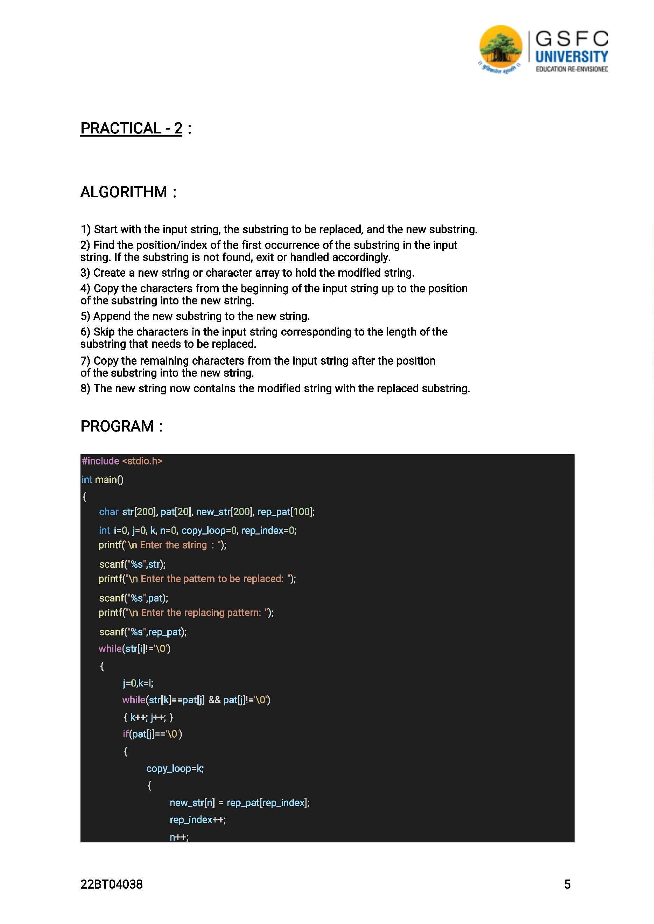

}

}

new_str[n] = str[copy_loop];

i++;

copy_loop++;

n++;

}

new str[n]='\0';

printf("\n The new string is : %s",new_str);

}

OUTPUT :

Enter a string: hello world

Enter a substring to replace: world

Enter the new substring: there

Resulting string: hello there

PRACTICAL - 3 : WAP to sort the names in ascending order.

ALGORITHM :

1) Create an array to hold the names.

2) Read the names into the array.

3) Use a sorting algorithm like bubble sort, selection sort, or insertion sort to

sort the names in ascending order.

4) Compare each pair of adjacent names and swap them if they are out of order.

5) Repeat the comparison and swapping process until the entire array is sorted. 6) After the

sorting is complete, the names will be in ascending order.

PROGRAM :

#include <stdio.h>

#include <string.h>

#define MAX NAMES 10

int main()

{

char names[MAX_NAMES][100], temp[100];

22BT04038

6

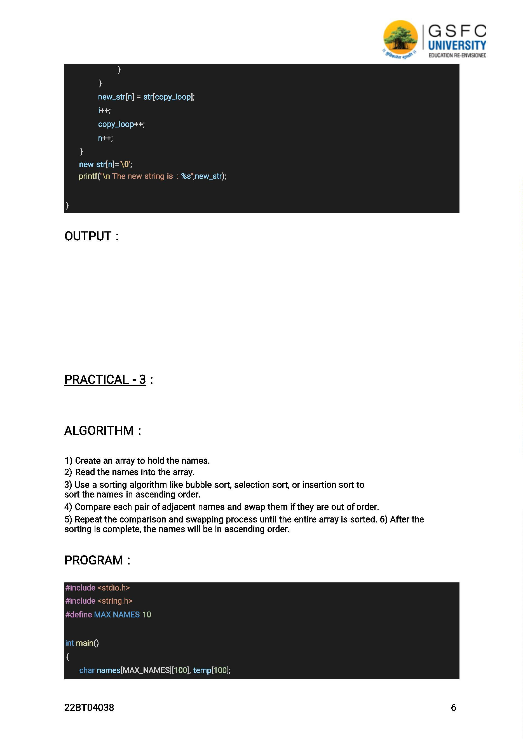

int i, j, n;

printf("Enter the number of names (up to %d): ", MAX_NAMES); scanf("%d", &n); printf("Enter %d

names:\n", n);

for (i = 0; i < n; i++)

{

scanf("%s", names[i]);

}

for (i = 0; i < n - 1; i++)

{

for (j = 0; j < n - i - 1; j++)

{

if (strcmp(names[j], names[j+1]) > 0)

{

strcpy(temp, names[j]); strcpy(names[j], names[j+1]);

strcpy(names[j+1], temp);

}

}

}

printf("Sorted names in ascending order:\n");

for (i = 0; i < n; i++)

{

printf("%s\n", names[i]);

}

return 0;

}

OUTPUT :

Enter the number of names (up to 10): 5

Enter 5 names:

Alice

Charlie

Eve

Bob

David

Sorted names in ascending order:

Alice

Bob

Charlie

David

Eve

22BT04038

7

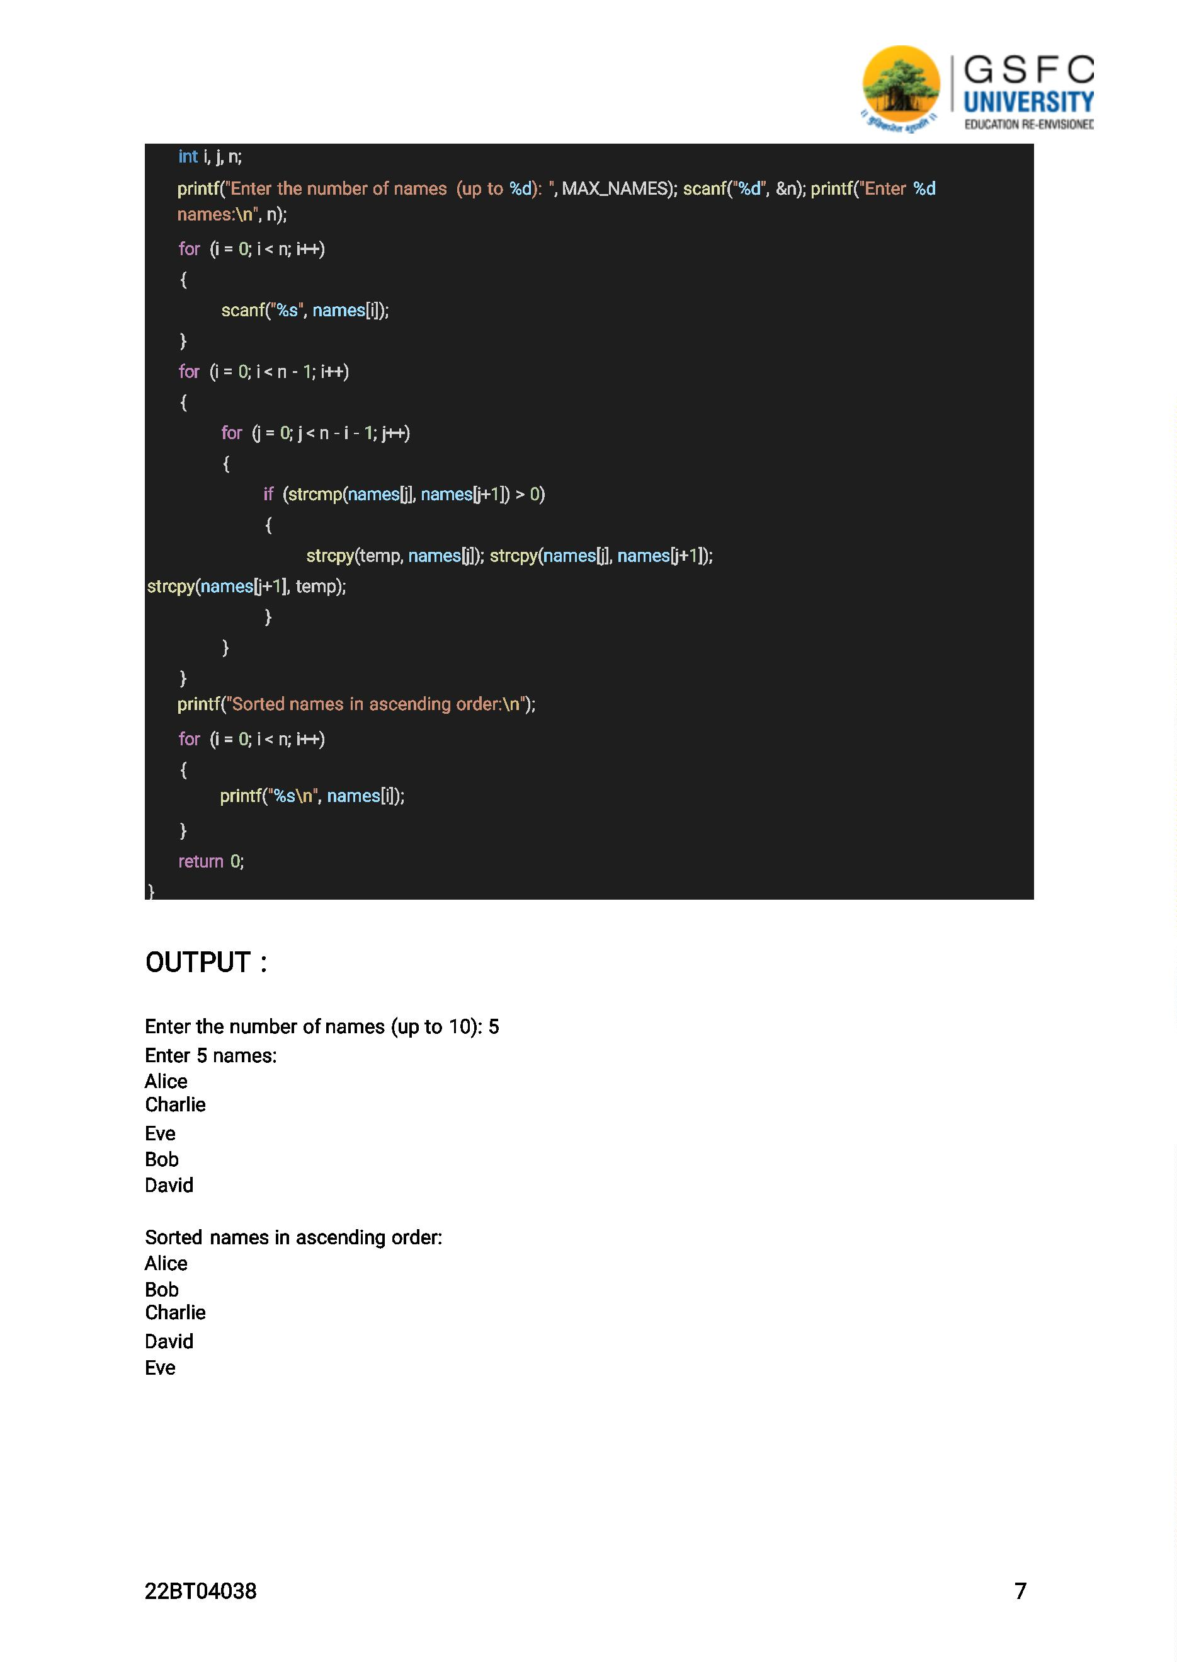

PRACTICAL - 4 : WAP to create a database of 5 students for 3 subjects

using arrays.

ALGORITHM :

1) Create arrays to store the student data. You will need an array for each subject and for each

student's name.

2) Read the data for each student and each subject.

3) Store the data in the respective arrays.

4) Repeat steps 2 and 3 for all the students and subjects.

5) Access the stored data as needed for further processing or display.

PROGRAM :

#include<iostream>

using namespace std;

int main()

{

int marks[5][3],high,sum,i=0,j=0;

string nam[5];

cout<<"Enter the data required : "<<endl;

for(i=0;i<5;i++)

{

cout<<"Enter the name of the student :";

cin>>nam[i];

cout<<"Enter the marks of C++,DSA and DE :";

for(j=0;j<3;j++)

{

cin>>marks[i][j];

}

}

cout<<"Here are the results:";

for(i=0;i<5;i++)

{

j=0;

high = marks[i][j];

for(j=0;j<3;j++)

{

22BT04038

8

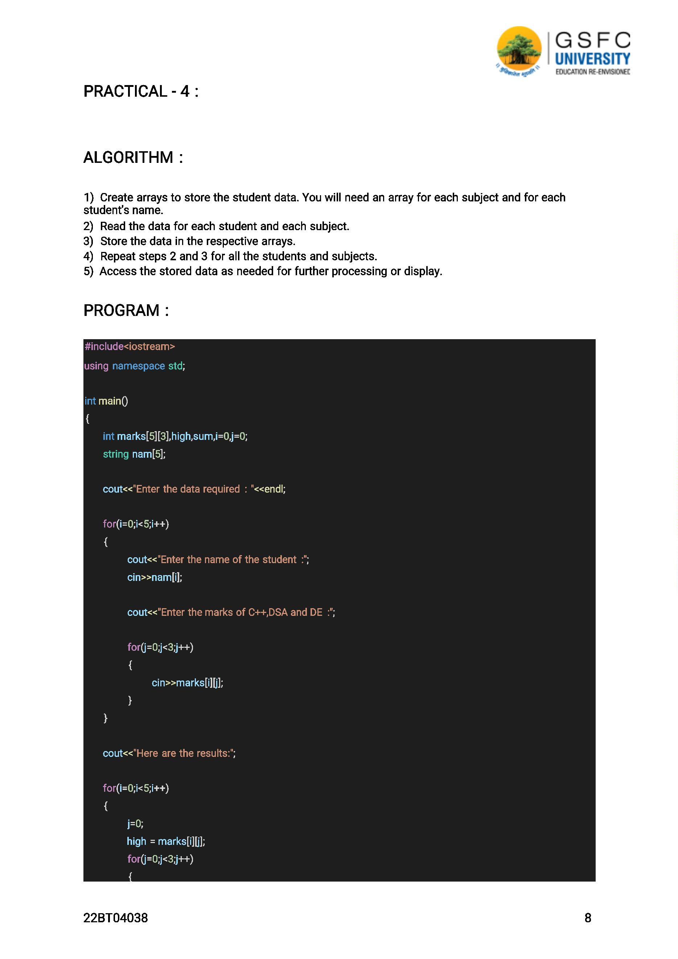

sum = sum + marks[i][j];

for(int k=0;k<2;k++)

if(high<marks[i][k+1])

{

high = marks[i][k+1];

}

}

float total = sum/3;

cout<<endl<<nam[i] <<" gets : "<<total<<"%"<<endl;

sum=0;

cout<<"Highest marks : "<<high<<endl;

}

}

OUTPUT :

Enter the marks for student 1:

Subject 1: 70

Subject 2: 80

Subject 3: 90

Enter the marks for student 2:

Subject 1: 80

Subject 2: 90

Subject 3: 100

Enter the marks for student 3:

Subject 1: 60

Subject 2: 70

Subject 3: 80

Enter the marks for student 4:

Subject 1: 50

Subject 2: 60

Subject 3: 70

Enter the marks for student 5:

Subject 1: 90

Subject 2: 80

Subject 3: 70

Results:

Student

Percent

80.00

90.00

70.00

60.00

Max Marks (Subject 1, Subject 2, Subject 3)

1

2

3

4

90, 90, 100

90, 90, 100

90, 80, 90

90, 80, 70

22BT04038

9

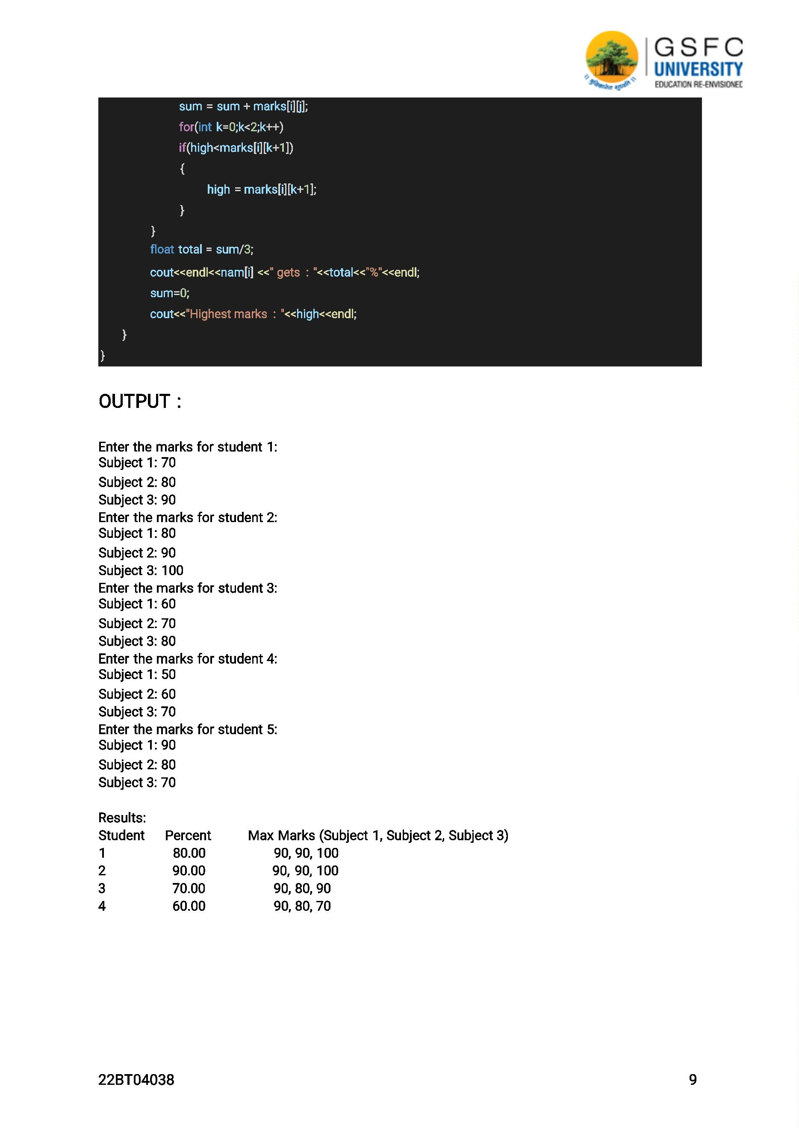

WEEK - 3

PRACTICAL - 1 : WAP to perform Push, Pop, and Peek operations on a stack.

ALGORITHM :

1) Create a stack data structure with an underlying array and a variable to keep track of the top

of the stack.

2) Initialise the top of the stack to -1, indicating an empty stack.

3) Implement a push

operation: a. Check if the

stack is full.

b. If not full, increment the top of the stack by 1. c. Insert the new element at the top of the

stack. 4) Implement a pop operation:

a. Check if the stack is empty.

b. If not empty, retrieve the element at the top of the stack. c. Decrement the top of the

stack by 1. 5) Implement a peek operation:

a. Check if the stack is empty.

b. If not empty, retrieve and return the element at the top of the stack.

PROGRAM :

#include <iostream>

using namespace std;

#define max 10

int top = -1;

class stack

{

public:

int st[max];

public:

int isEmpty()

{

if (top == -1)

{

return 1;

}

else

{

return 0;

}

}

int isFull()

22BT04038

10

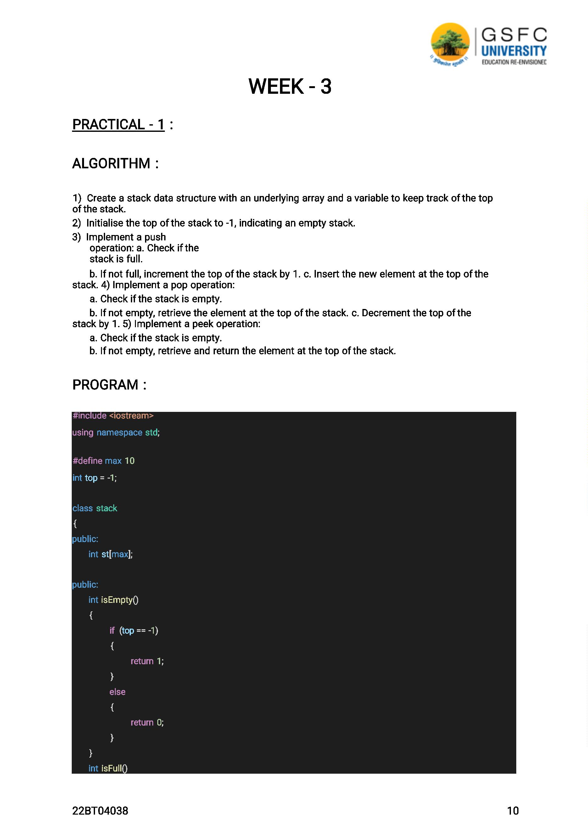

{

if (top == max-1)

{

return 1;

}

else

{

return 0;

}

}

void push(int a)

{

if(isFull())

{

cout << "The stack is full.";

}

else

{

top++;

st[top] = a;

}

}

void pop()

{

if (isEmpty())

{

cout << "The stack is Empty.";

}

else

{

st[top] = 0;

top--;

}

}

void print()

{

for (int i = 0; i <= top; i++)

{

cout << st[i] << endl;

}

};

22BT04038

11

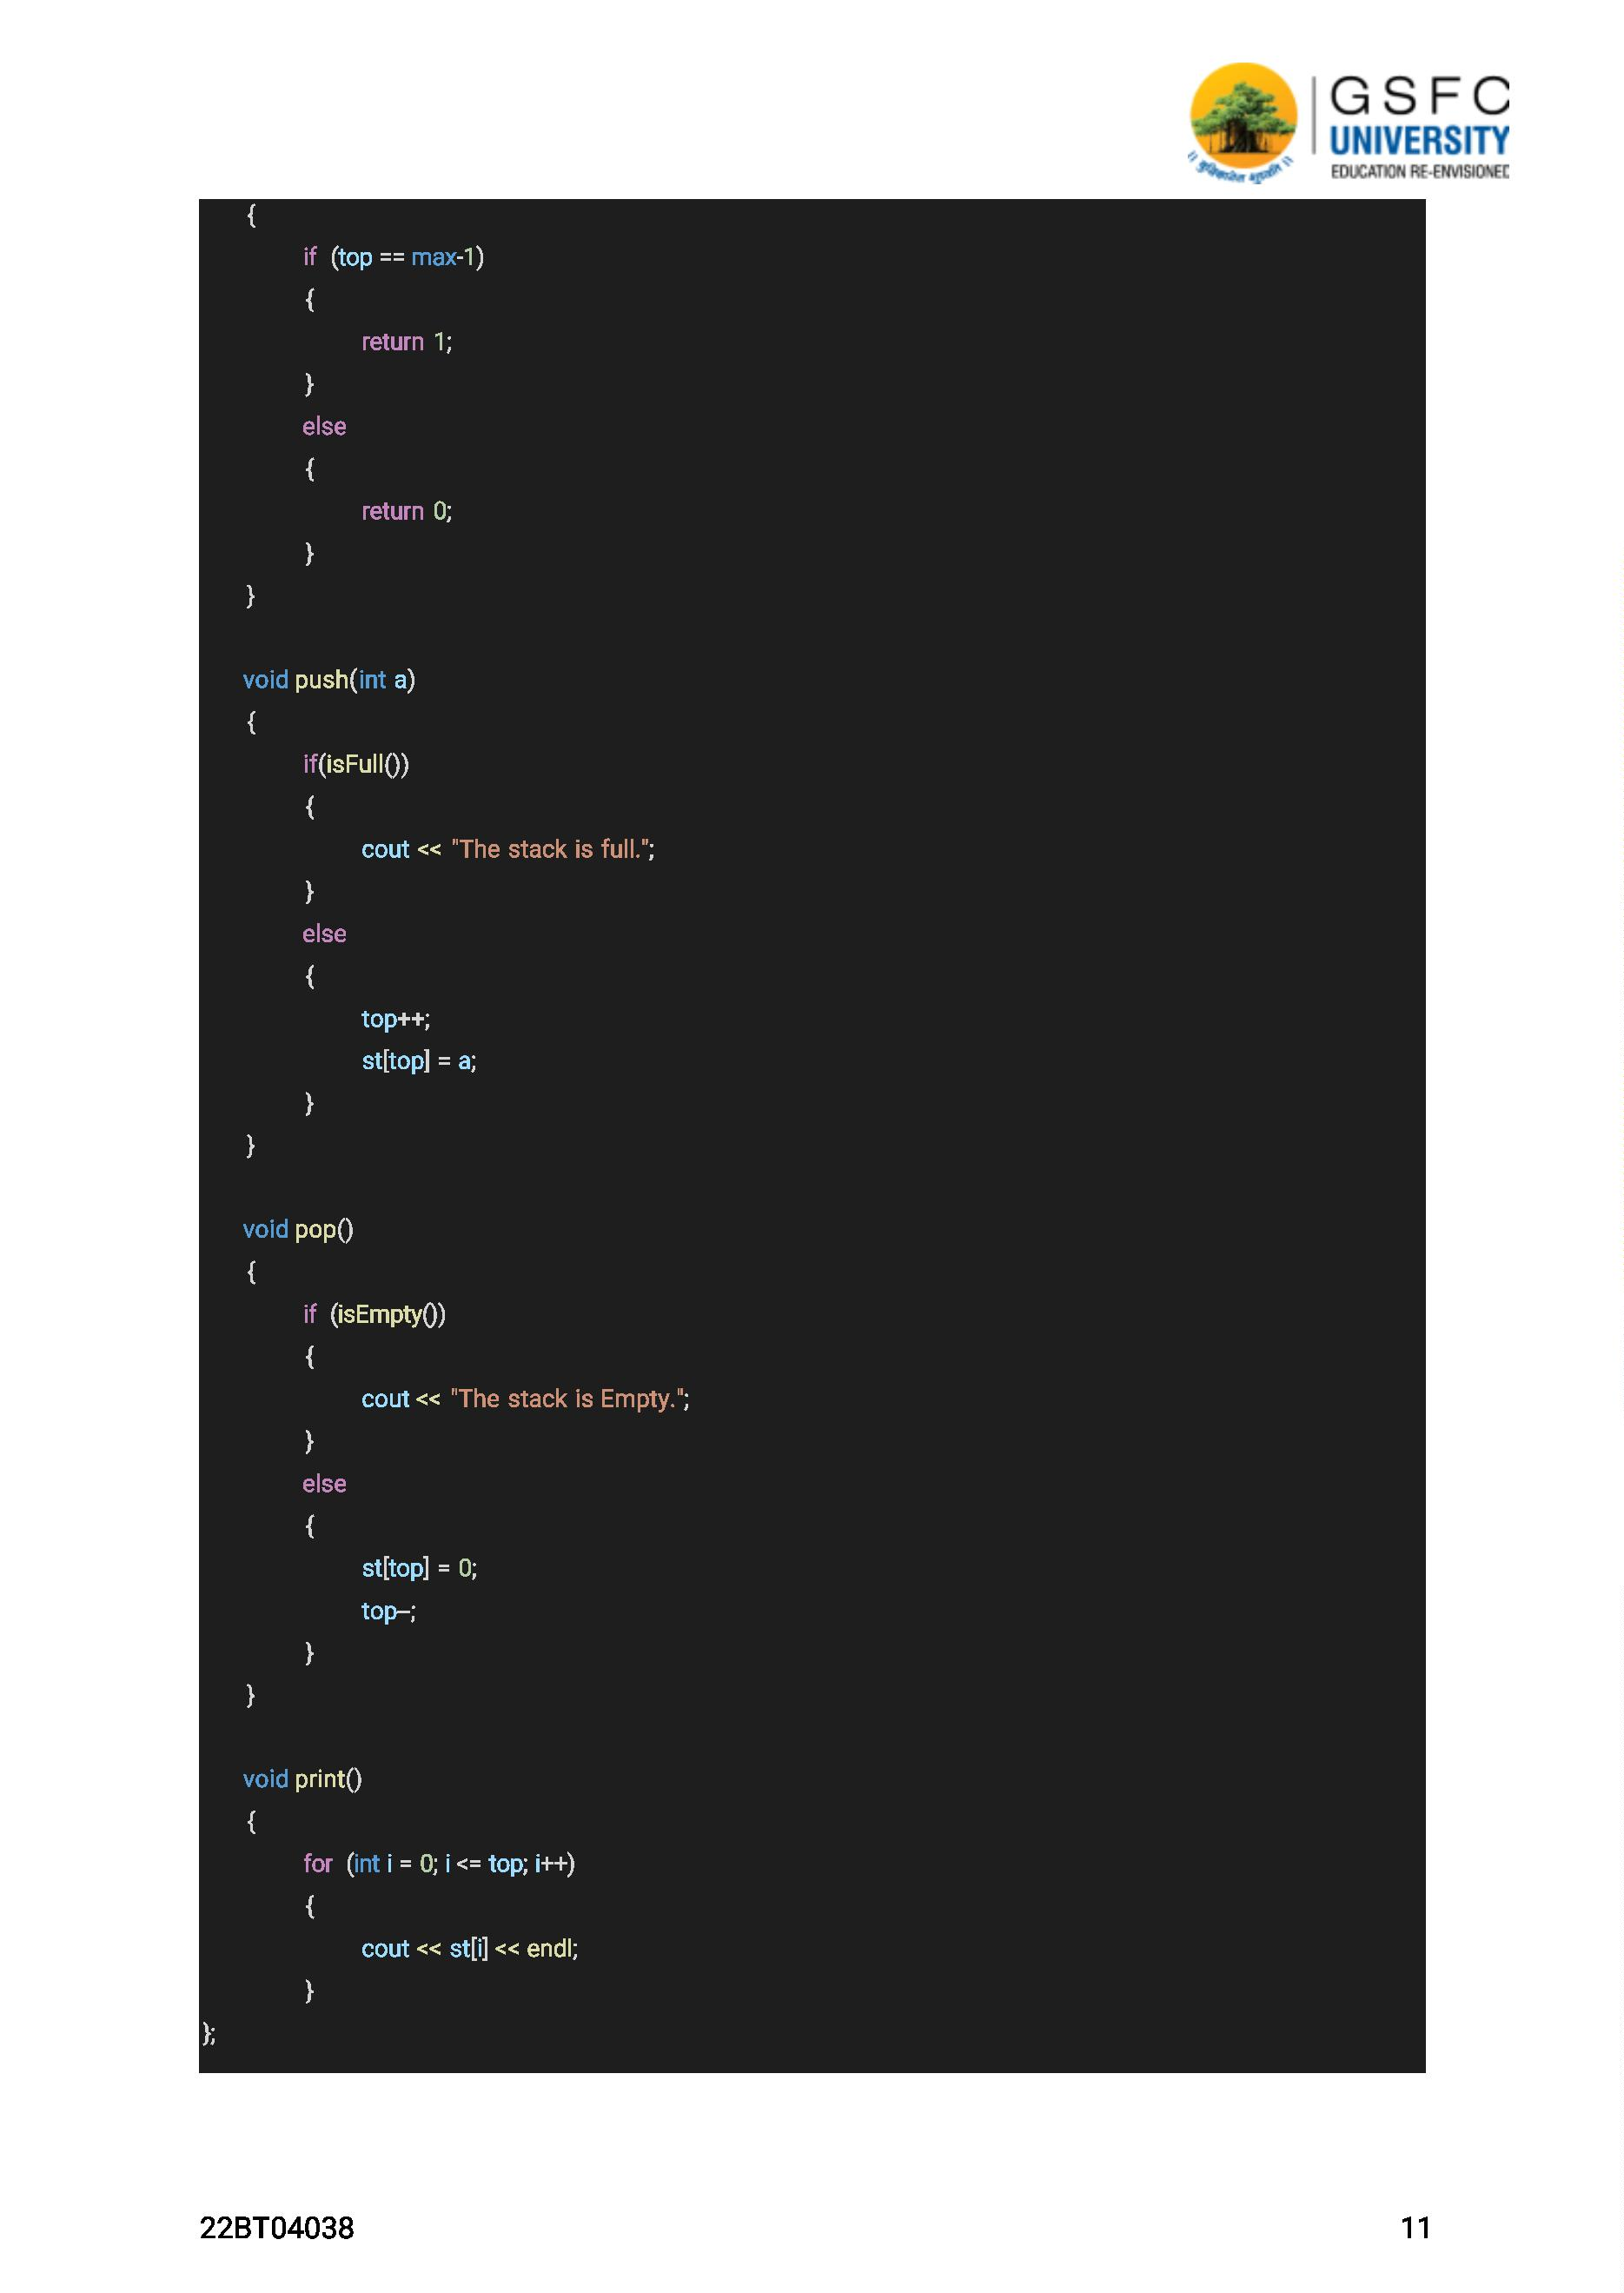

int main()

{

stack s;

s.push(1);

s.push(2);

s.push(3);

s.push(4);

s.push(5);

s.push(6);

s.push(7);

s.push(8);

s.push(9);

s.print();

cout<<endl;

s.pop();

s.pop();

s.pop();

s.pop();

s.pop();

s.print();

}

OUTPUT :

1

2

3

4

5

6

7

8

9

1

2

3

4

22BT04038

12

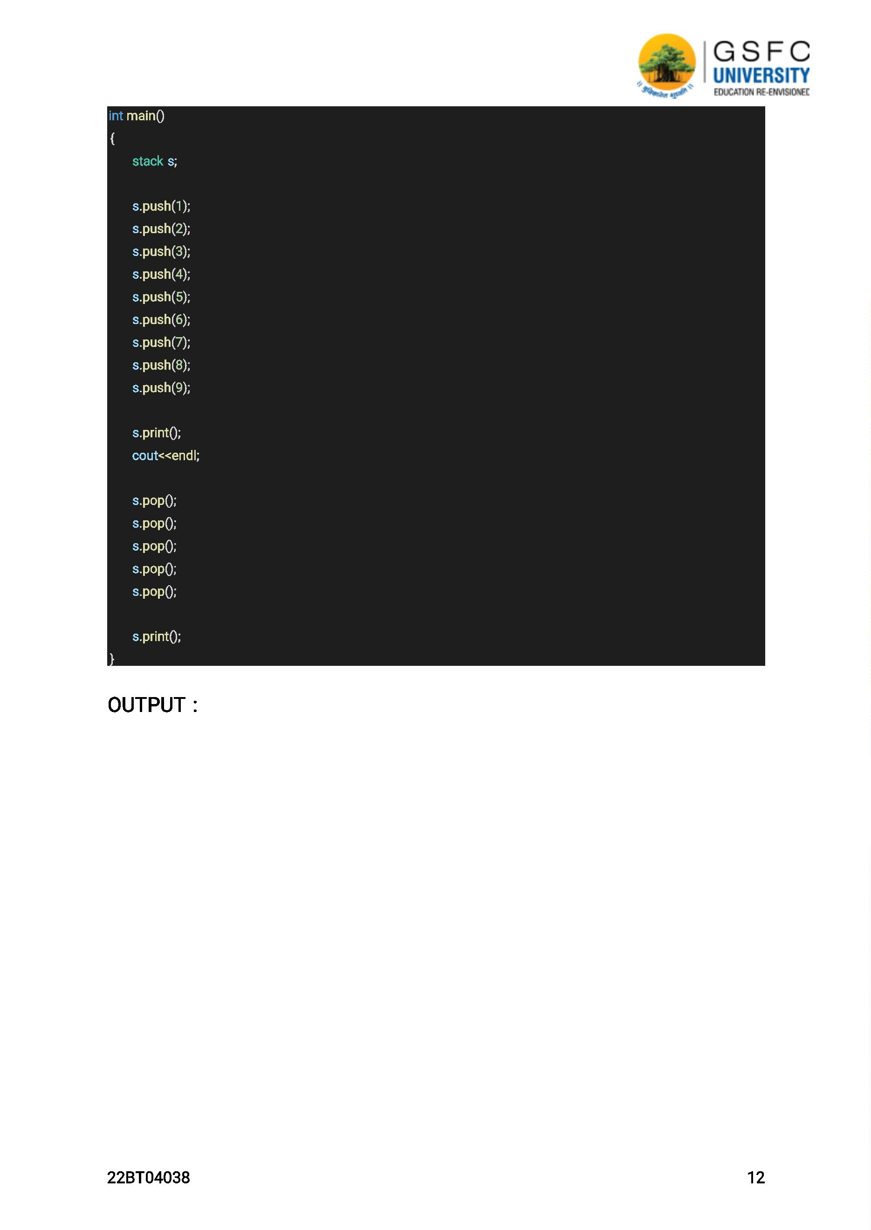

WEEK - 4

PRACTICAL - 1 : Implement a program to convert infix notation to

postfix notation using stack.

ALGORITHM :

1) Create an empty stack to hold operators.

2) Create an empty list to store the output in postfix notation.

3) Scan the infix expression from left to right.

4) If the current token is an operand (number or variable), append it to the output list. 5) If the

current token is a left parenthesis '(', push it onto the stack.

6) If the current token is an operator (+, -, *, /, etc.), do the following: a. While there are

operators at the top of the stack with greater precedence or equal precedence and left

associativity, pop them from the stack and append them to the output list. b. Push the current

operator onto the stack.

7) If the current token is a right parenthesis ')', do the following: a. While the top of the stack is not

a left parenthesis, pop operators from the stack and append them to the output list. b. Pop the left

parenthesis from the stack and discard it.

8) After scanning the entire infix expression, pop any remaining operators from the stack and

append them to the output list.

9) The output list now contains the infix expression converted to postfix notation.

PROGRAM :

#include <stdio.h>

#include <stdlib.h>

#include <string.h>

#define MAX_EXPRESSION_LENGTH 100

struct stack

{

char data[MAX_EXPRESSION_LENGTH];

int top;

};

void push(struct stack *s, char c)

{

if (s->top == MAX_EXPRESSION_LENGTH - 1)

{

printf("Error: Stack overflow\n");

exit(EXIT_FAILURE);

}

s->top++;

s->data[s->top] = c;

22BT04038

13

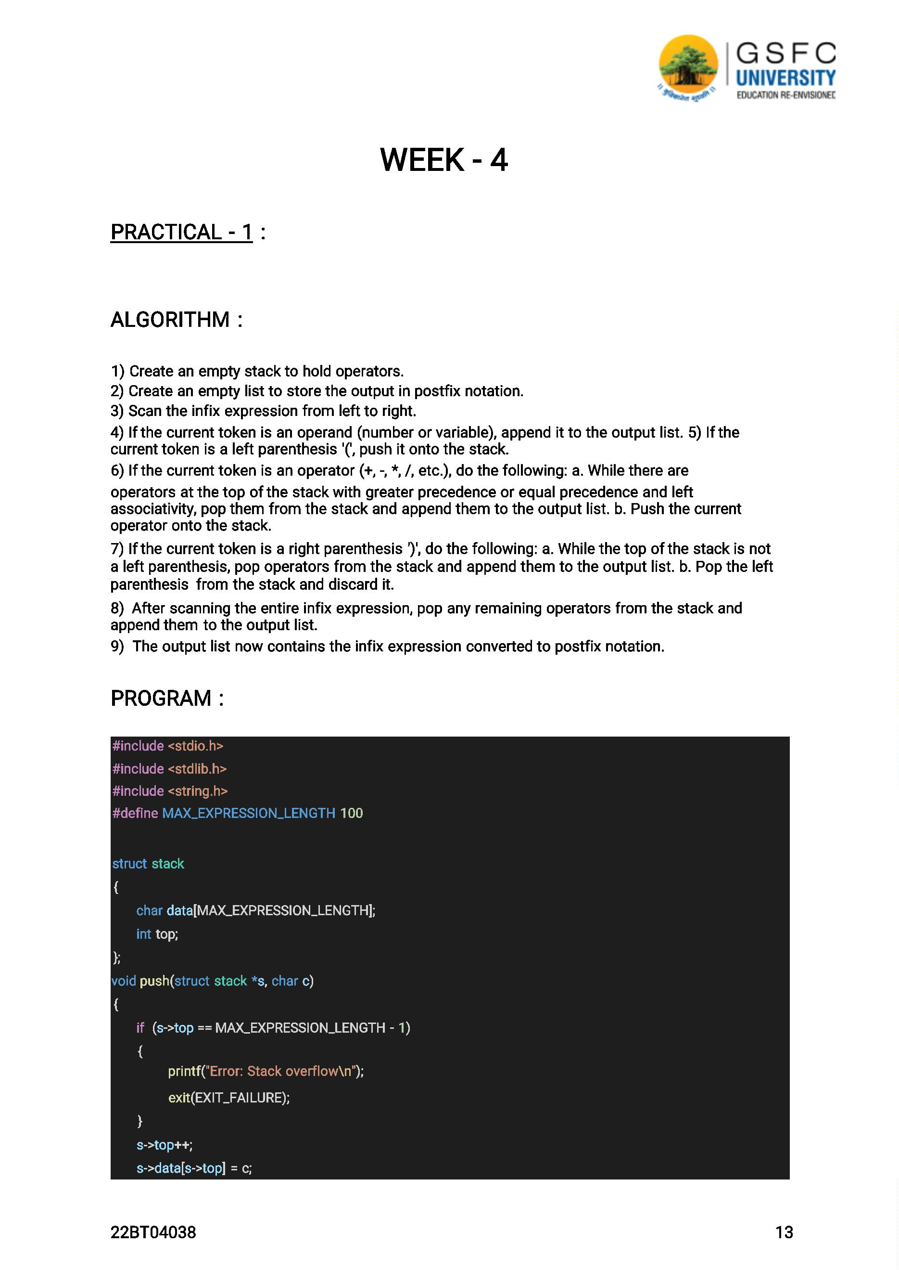

}

char pop(struct stack *s)

{

if (s->top == -1)

{

printf("Error: Stack underflow\n");

exit(EXIT_FAILURE);

}

char c = s->data[s->top];

s->top--;

return c;

}

int precedence(char op)

{

if (op == '+' || op == '-')

{

return 1;

}

else if (op == '*' || op == '/')

{

return 2;

}

else if (op == '^')

{

return 3;

}

else

{

return -1;

}

}

int is_operator(char c)

{

return (c == '+' || c == '-' || c == '*' || c == '/' || c == '^');

}

void infix_to_postfix(char *infix, char *postfix)

{

struct stack s;

s.top = -1;

int i, j;

for (i = 0, j = 0; infix[i] != '\0'; i++)

{

if (infix[i] == '(')

{

22BT04038

14

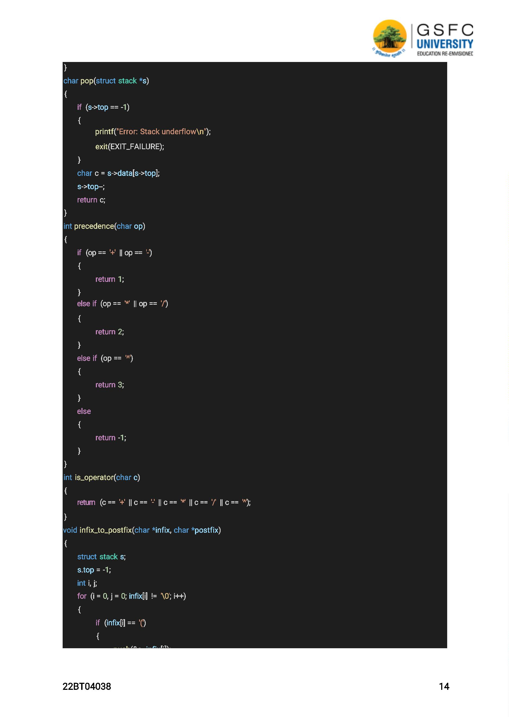

}

else if (infix[i] == ')')

{

while (s.top != -1 && s.data[s.top] != '(')

{

postfix[j++] = pop(&s);

}

if (s.top == -1)

{

printf("Error: Mismatched parentheses\n");

exit(EXIT_FAILURE);

}

pop(&s);

}

else if (is_operator(infix[i]))

{

while (s.top != -1 && precedence(infix[i]) <= precedence(s.data[s.top]))

{

postfix[j++] = pop(&s);

}

push(&s, infix[i]);

}

else

{

postfix[j++] = infix[i];

}

}

while (s.top != -1)

{

if (s.data[s.top] == '(')

{

printf("Error: Mismatched parentheses\n");

exit(EXIT_FAILURE);

}

postfix[j++] = pop(&s);

}

postfix[j] = '\0';

}

int main()

{

char infix[MAX_EXPRESSION_LENGTH];

char postfix[MAX_EXPRESSION_LENGTH];

printf("Enter infix expression: ");

fgets(infix, MAX_EXPRESSION_LENGTH, stdin);

22BT04038

15

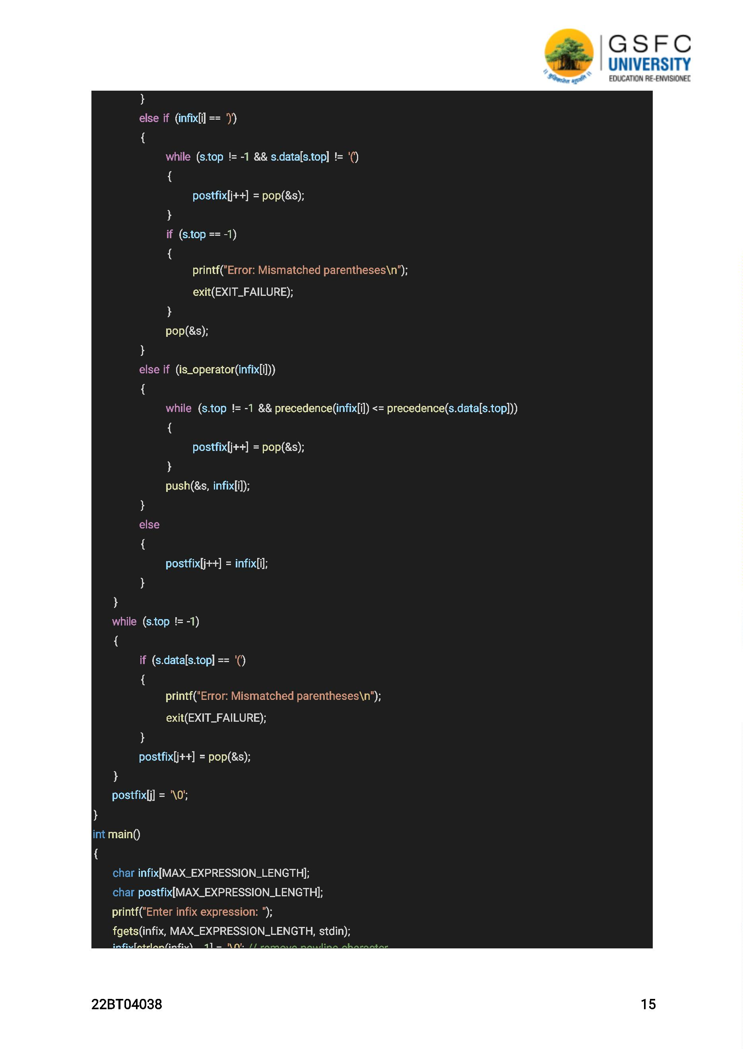

infix_to_postfix(infix, postfix);

printf("Postfix expression: %s\n", postfix);

return 0;

}

OUTPUT :

Enter infix expression: 3+4*5/(6-2)

Postfix expression: 345*62-/+

PRACTICAL - 2 : Write a program to implement QUEUE using arrays

that performs following operations:

a) INSERT

b) DELETE

c) DISPLAY

ALGORITHM :

1) Initialise an empty array with a fixed size and set front and rear pointers to -1.

2) INSERT operation:

a. Check if the queue is full by comparing rear with the array size.

b. If the queue is full, display an overflow message.

c. If the queue is not full:

i. Increment rear by 1.

ii. Read the element to be inserted.

iii. Store the element at the rear position in the array.

3) DELETE operation:

a. Check if the queue is empty by comparing front with rear.

b. If the queue is empty, display an underflow message.

c. If the queue is not empty:

i. Increment front by 1.

ii. Retrieve and display the element at the front position from the array.

4) DISPLAY operation:

a. Check if the queue is empty by comparing front with rear.

b. If the queue is empty, display a message indicating that the queue is empty.

c. If the queue is not empty:

i. Start a loop from front + 1 to rear.

ii. Retrieve and display each element in the array.

5) Repeat steps 2-4 as needed.

22BT04038

16

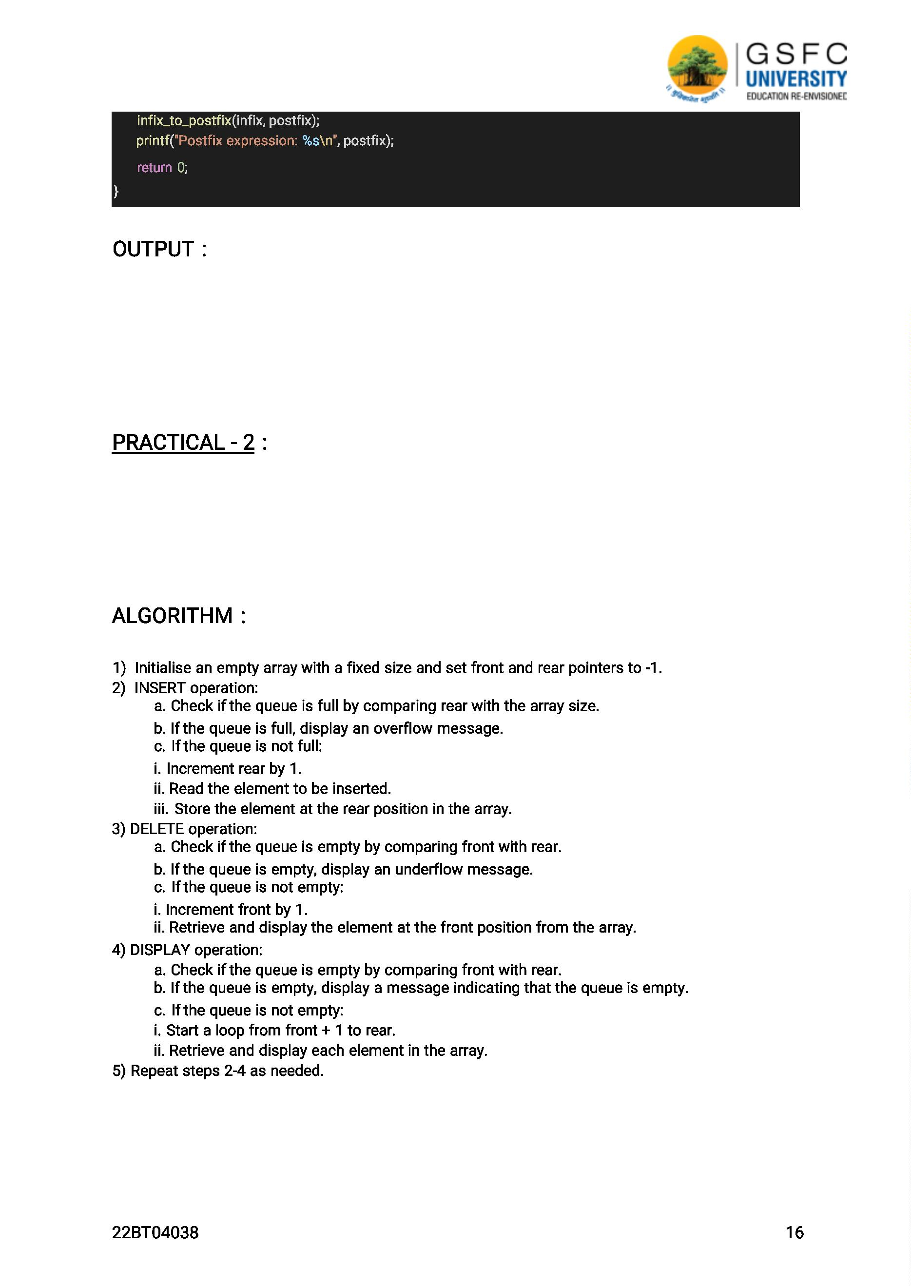

PROGRAM :

#include <stdio.h>

#define MAXSIZE 10

int queue[MAXSIZE];

int front = -1;

int rear = -1;

void insert(int item)

{

if (rear == MAXSIZE - 1)

{

printf("Queue is full\n");

return;

}

else

{

if (front == -1)

{

front = 0;

}

rear++;

queue[rear] = item;

printf("Inserted element: %d\n", item);

}

}

void Delete()

{

if (front == -1 || front > rear)

{

printf("Queue is empty\n");

return;

}

else

{

printf("Deleted element: %d\n", queue[front]);

front++;

if (front > rear)

{

front = rear = -1;

}

}

}

22BT04038

17

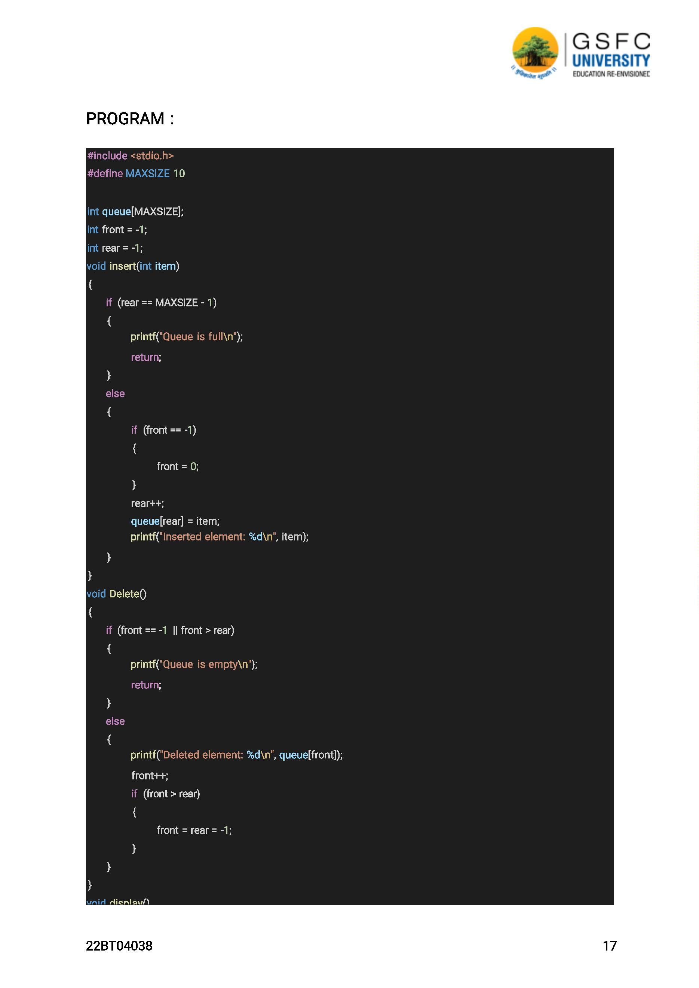

{

if (front == -1)

{

printf("Queue is empty\n");

}

else

{

int i;

printf("Queue elements: ");

for (i = front; i <= rear; i++)

{

OUTPUT:

printf("%d ", queue[i]);

}

printf("\n");

}

}

int main()

{

int choice, item;

while (1)

{

printf("1. Insert\n");

printf("2. Delete\n");

printf("3. Display\n");

printf("4. Quit\n");

printf("Enter your choice: ");

scanf("%d", &choice);

switch (choice)

{

case 1:

printf("Enter element to be inserted: ");

scanf("%d", &item);

insert(item);

break;

case 2:

Delete ();

break;

case 3:

display();

break;

case 4:

return 0;

default:

printf("Invalid choice\n");

22BT04038

18

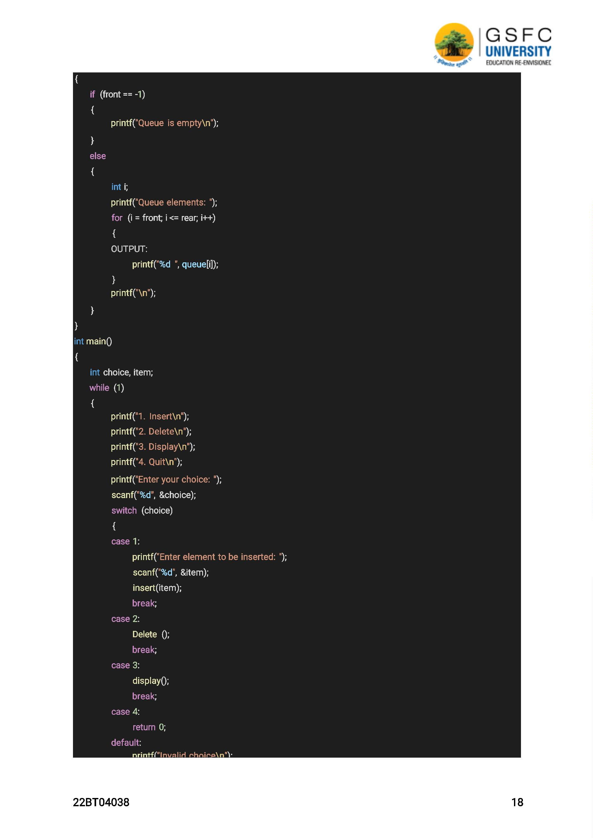

}

}

}

OUTPUT :

1. Insert

2. Delete

3. Display

4. Quit

Enter your choice: 1

Enter element to be inserted: 10

Inserted element: 10

1. Insert

2. Delete

3. Display

4. Quit

Enter your choice: 1

Enter element to be inserted: 20

Inserted element: 20

1. Insert

2. Delete

3. Display

4. Quit

Enter your choice: 1

Enter element to be inserted: 30

Inserted element: 30

1. Insert

2. Delete

3. Display

4. Quit

Enter your choice: 3

Queue elements: 10 20 30

1. Insert

2. Delete

3. Display

4. Quit

Enter your choice: 2

Deleted element: 10

1. Insert

2. Delete

3. Display

4. Quit

Enter your choice: 3

Queue elements: 20 30

1. Insert

2. Delete

3. Display

4. Quit

Enter your choice: 4

22BT04038

19

